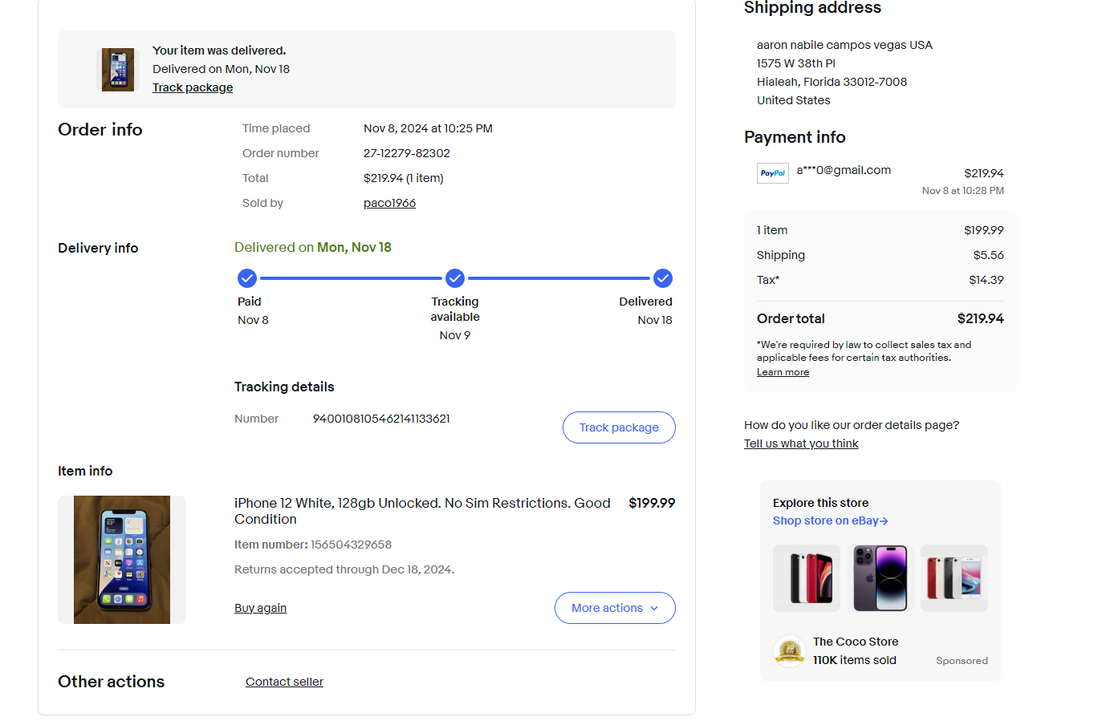

**Tracking details**

Number

9400108105462141133621

RUC:10712523153